Faculty: Average Salaries: AAUP; links to data below; + national data table

Rank | FPU | KSC | Plymouth St | St. Anselm | UNH | Merrimack C | Stonehill
Professor | $77,200 | $101,400 | $90,700 | $94,900 | $130,200 | $107,500 | $108,300
Assoc Prof | $65,000 | $81,900 | $75,500 | $78,100 | $102,600 | $86,500 | $82,500
Asst. Prof. | $63,000 | $68,200 | $63,900 | $62,600 | $87,300 | $77,000 | $63,100
Instructor | $54,500 | n/a | n/a | n/a | n/a |  | $50,800

Floor Salaries [FPU CBA 2016-19]
 | FPU
Professor | $65,000
Assoc. Prof. | $55,000
Asst. Prof. | $47,000
Instructor | $42,000

Faculty Salaries: http://eraven.franklinpierce.edu/s/dept/hr/2ndHR/RFF/2016-19CBA.pdf; CBA:

“Year: Raise Conditional 1/1/2016 – 8/31/2016 1%
9/1/2016 – 8/31/2017 1 1/2%
9/1/2017 – 8/31/2018 1 1/2%
9/1/2018 – 8/31/2019 1 1/2%
20.2.1 The annual increase will not be awarded in the contract year hired.
20.3 Promoted Faculty shall receive the higher of the new rank floor salary as shown above or the increase for the promotion added to their current salary. The annual percentage increase will then be applied to this amount.
20.3.1 Increases for promotion in rank: Promotion Increase
Instructor to Assistant Professor $1,500
Assistant Professor to Associate Professor $1,850
Associate Professor to Professor $2,250
________________________________________________________________________
2016-17 AAUP Faculty Compensation Survey
The annual AAUP Faculty Compensation Survey is the largest independent source of data on full-time faculty salary and benefits at two- and four-year colleges and universities in the United States. The 2017 iteration of the survey includes information on salary and benefits for more than 380,000 faculty members from 1,022 institutions in all 50 states and Puerto Rico. The survey, along with the accompanying "Annual Report on the Economic Status of the Profession," is published each year in the March–April issue of Academe, the AAUP's magazine. Inside Higher Ed below presents these data in an easily searchable database.
https://www.insidehighered.com/aaup-compensation-survey/state/new-hampshire-1490
https://www.insidehighered.com/aaup-compensation-survey/state/massachusetts-1482/state/new-hampshire-1490
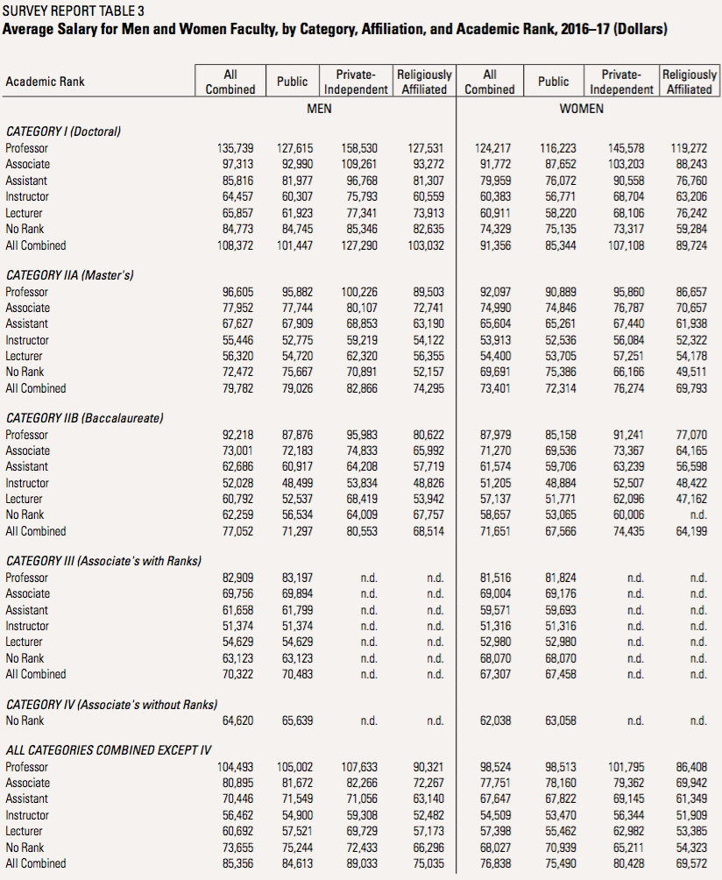
https://www.insidehighered.com/news/2017/04/11/aaup-faculty-salaries-slightly-budgets-are-balanced-backs-adjuncts-and-out-state

